March 18, 2022

Michigan Office of Administrative Hearings and Rules
Administrative Rules Division
611 W. Ottawa
Lansing, MI 48909

Dear Director:

Enclosed please find a revised JCAR report concerning the Public Health Code –
Disciplinary Rules, MOAHR # 2021 037.

As you know, this form has been revised since the JCAR report for this rule set was
originally filed. At that time, it was the policy of the Bureau of Professional Licensing
to include commenters’ names in box 4 only if the commenter was opposed to the entire
rule set, not if the commenter was opposed to a specific rule change.

The revised version of this form now indicates that there were 3 commenters who opposed
changes made to specific rules, and those rules have been identified.

Would you please replace the JCAR report currently associated with this rule set with the
attached, provide a copy of the revised report to the JCAR committee, and publish the revised report in the Michigan Register?

Thank you for your attention to this matter.

Sincerely,
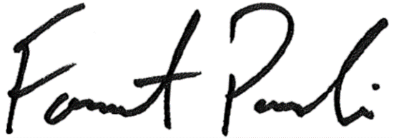
Forrest Pasanski
Enforcement Division Director

