DEPARTMENT OF LICENSING AND REGULATORY AFFAIRS

DIRECTOR’S OFFICE

CONSTRUCTION CODE

Filed with the secretary of state on

These rules become effective 120 days after filing with the secretary of state.

(By authority conferred on the director of the department of licensing and regulatory affairs by section 4 of the Stille-DeRossett-Hale single state construction code act, 1972 PA 230, MCL 125.1504, and Executive Reorganization Order Nos. 2003-1, and 2008-4, and 2011-4, MCL 445.2011, 445.2025, and 445.2030)

R 408.31059, R 408.31060b, R 408.31066, and R 408.31069 of the Michigan Administrative Code is are amended, and R 408.31060c, R 408.31060e, R 408.31061, R 408.31062, R 408.31063, R 408.31063a, R 408.301064, R 408.31065, R 408.31070, R408.31071, and R 408.31071a of the Michigan Administrative Code are rescinded, as follows:

PART 10. MICHIGAN UNIFORM ENERGY CODE

R 408.31059 Applicable code.
Rule 1059. The residential provisions of the international energy conservation code, 2015 2021 edition, including appendix RB except for sections R104.2 to R104.5, R107.2 to R107.5, R301.2, R301.3, R402.3.2, and Table R303.1.3(3), R109.1 to R109.4, R110.1 to R110.4, and appendix RA govern the energy efficiency for the design and construction of residential buildings, and, with exceptions noted, the international energy conservation code is adopted by reference in these rules. The provisions contained in Appendix RB are specifically adopted and authorized as mandatory requirements. The provisions contained in Appendix RC are specifically adopted and authorized as permissive guidelines and shall not be mandated by an enforcing agency. All references to the international building code, international residential code, international energy conservation code, international electrical code, international existing building code, international mechanical code, and international plumbing code mean the Michigan building code, Michigan residential code, Michigan energy code, Michigan electrical code, Michigan rehabilitation code for existing buildings, Michigan mechanical code, and Michigan plumbing code, respectively. The Michigan energy code is available for inspection or purchase at the Okemos office of the Michigan Department of Licensing and Regulatory Affairs, Bureau of Construction Codes, 2501 Woodlake Circle, Okemos, 611 West Ottawa Street, Lansing, Michigan 48933 48864, at a cost as of the time of adoption of these rules of $52.00. or may be purchased from the International Code Council, 500 New Jersey Avenue, N.W., 6th Floor, Washington, D.C. 20001. The code may be purchased from the International Code Council, through the bureau’s website at www.michigan.gov/bcc, at a cost as of the time of adoption of these rules of $52.00.

R 408.31060b FeesPermits.
Rule 1060b. Section 107.1R104.1 of the code is amended to read as follows:
107.1R104.1. Payment of feesPermits. The fees prescribed by the act shall be paid to the enforcing agency of the jurisdiction before a permit to begin work for new construction, alteration, removal, demolition, or other building operation may be issued. In addition, an amendment to a permit necessitating an additional fee shall not be approved until the additional fee has been paid. Any owner or owner’s authorized agent who intends to construct, enlarge, alter, repair, move, demolish or change the occupancy of a building or structure, or to erect, install, enlarge, alter, repair, remove, convert, or replace any electrical, gas, mechanical, plumbing or solar panel system, the installation of which is regulated by this code, or to cause any such work to be performed, shall first apply to the building official and obtain the required permit.

R 408.31060c Board of appeals. Rescinded.
Rule 1060c. Section 109.1 and 109.3 of the code are amended to read as follows:
109.1 Means of appeal. (1) An interested person may appeal a decision of the enforcing agency to the board of appeals in accordance with the act. An application for appeal shall be based on both of the following:
(a) A claim that the true intent of the code or the rules governing construction have been incorrectly interpreted.
(b) The provisions of the code do not apply, or equal or better form of construction is proposed.
(2) The decision of a local board of appeals may be appealed to the construction code in accordance with the act and time frames.
Exceptions: Requests for barrier free design exception shall e in accordance with 1966 PA 1, MCL 125.1352 to 125.1356.
109.3 Qualifications. The board of appeals shall consist of members who are qualified in accordance with the act.

R 408.31060e Climate Zones. Rescinded.
Rule 1060e. Section 301.1 and Tables 301.1 and 301.3(2) of the code are amended and Figure 301.1a is added to the code to read as follows:
301.1 General. Climate zones from figures 301.1, 301.1a or table 301.1 shall be used in determining the applicable requirements of this code.

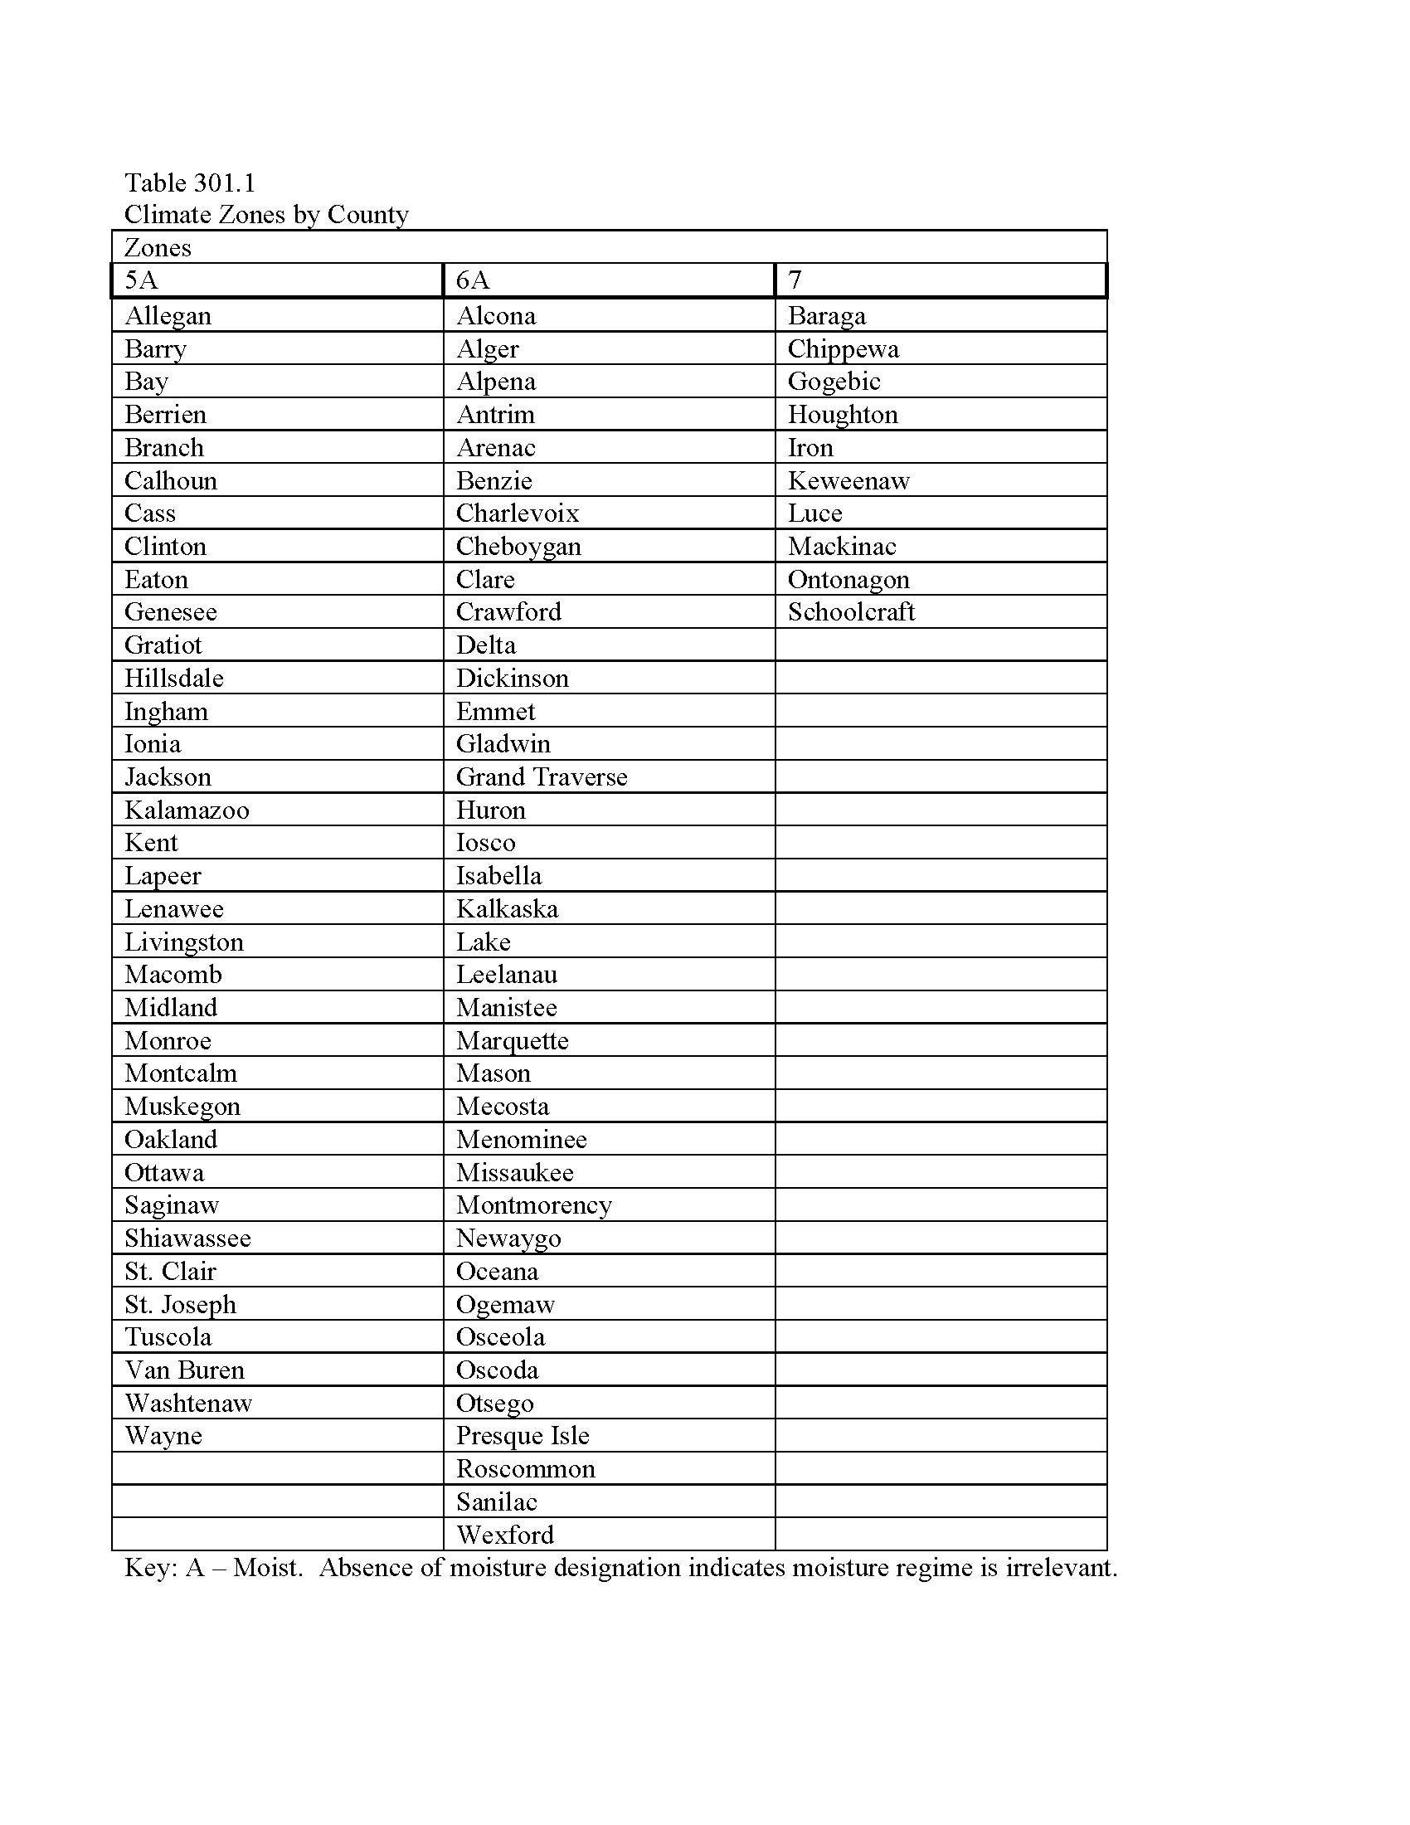
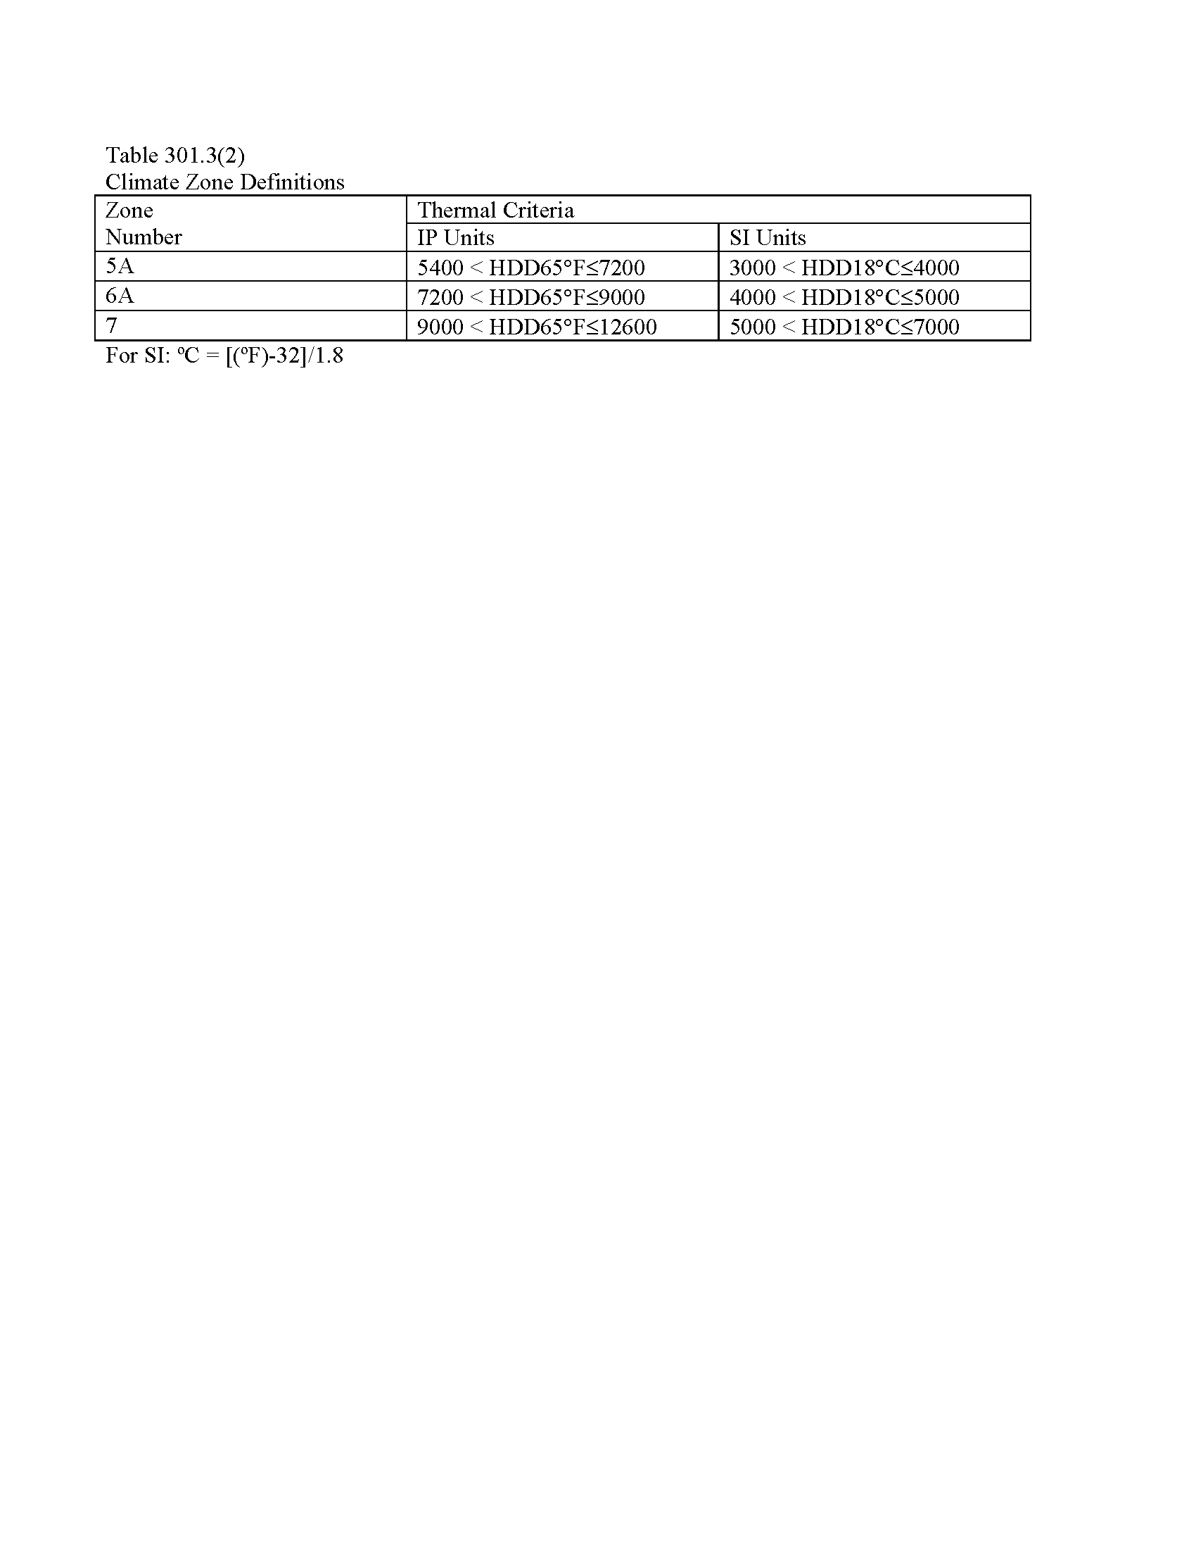
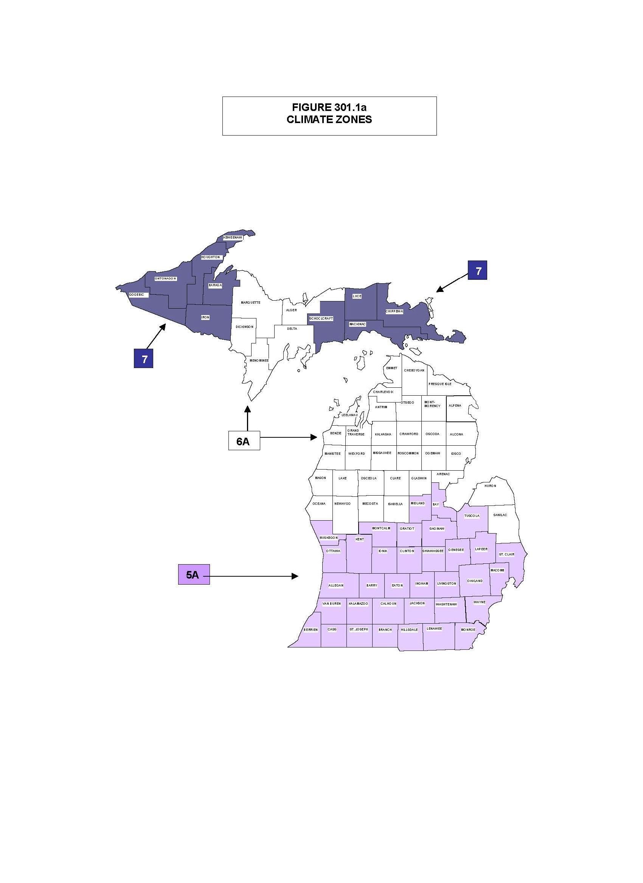

Editor's Note: An obvious error in R 408.31060e was corrected at the request of the promulgating agency, pursuant to Section 56 of 1969 PA 306, as amended by 2000 PA 262, MCL 24.256. The rule containing the error was published in Michigan Register, 2010 MR 21. The memorandum requesting the correction was published in Michigan Register, 2011 MR 5.

R 408.31061 Certificate. Rescinded.
Rule 1061. Section 401.3 of the code is amended to read as follows:
401.3 Certificate. A permanent certificate shall be posted on or in the electrical distribution panel, and shall meet all of the following:
(a) Be affixed or attached so it does not cover or obstruct the visibility of the circuit directory label, service disconnect label, or other required labels.
(b) Be completed by the builder or registered design professional.
(c) List the predominant R-values of insulation installed in or on ceiling/roof, walls, foundation (slab, basement wall, crawlspace wall and/or floor) and ducts outside conditioned spaces and U-factors for fenestration. If there is more than 1 value for each component, then the certificate shall list the value covering the largest area.
(d) List the types and efficiencies of heating, cooling and service water heating equipment.
(e) If a gas-fired unvented room heater, electric furnace, or baseboard electric heater is installed in the residence, then the certificate shall list "gas-fired unvented room heater," as appropriate. An efficiency shall not be listed for gas-fired unvented room heaters, electric furnaces, or electric baseboard heaters.

R 408.31062 Fenestration product rating. Rescinded.
Rule 1062. Section303.1.3 of the code is amended to read as follows:
303.1.3. Fenestration product rating. U-factors of fenestration products (windows, doors and skylights) shall be determined in accordance with NFRC 100 by an accredited, independent laboratory, and labeled and certified by the manufacturer. Products lacking such a labeled U-factor shall be assigned a default U-factor from Table 303.1.3(1) or 303.1.3(2).
Exception: Computer simulations by independent NFRC certified laboratories or approval under section 21 of 1972 PA 230, MCL 125.1521 are considered in compliance with this section.

R 408.31063 Insulation and fenestration criteria. Rescinded.
Rule 1063. Insulation and fenestration criteria. Table R402.1.1 of the code is amended to read as follows:

TABLE R 402.1.1
INSULATION AND FENESTRATION REQUIREMENTS BY COMPONENTa
CLIMATE ZONE | FENESTRATION U-FACTOR | SKYLIGHT^{b}  U-FACTOR | CEILING R-Value | WOOD FRAME WALL R-VALUE | MASS WALL R- VALUE^{g} | FLOOR  R-VALUE | BASEMENT^{c} WALL R-VALUE | SLAB ^{d}  R-VALUE AND DEPTH | CRAWL SPACE^{c}  WALL  R-VALUE
5A | 0.32 | 0.55 | 38 | 20 or  13 + 5^{f} | 13/17 | 30e | 10/13 | 10, 2ft | 15/19
6A | 0.32 | 0.55 | 49 | 20 or 13 + 5^{f} | 15/20 | 30e | 15/19 | 10, 4ft | 15/19
7 | 0.32 | 0.55 | 49 | 20 or 13 + 5^{f} | 19/21 | 38e | 15/19 | 10, 4ft | 15/19
a. R-values are minimums. U-factors are maximums. When insulation is installed in a cavity that is less than the label or design thickness of the insulation, the installed R-value of the insulation shall not be less than the R-values specified in the table.
b. The fenestration U-factor column excludes skylights.
c. “15/19” means R-15 continuous insulation on the interior or exterior of the home or R-19 cavity insulation at the interior of the basement wall. “15/19” may be met with R-13 cavity insulation on the interior of the basement wall plus R-5 continuous insulation on the interior or exterior of the home. “10/13” means R-10 continuous insulation on the interior or exterior of the home or R-13 cavity insulation at the interior of the basement wall.
d. R-5 shall be added to the required slab edge R-values for heated slabs.
e. Or insulation sufficient to fill the framing cavity, R-19 minimum.
f. First value is cavity insulation, second is continuous insulation or insulated siding, so “13 + 5” means R-13 cavity insulation plus R-5 continuous insulation or insulated siding. If structural sheathing covers 40 % or less of the exterior, continuous insulation R-value may be reduced by no more than R-3 in the locations where structural sheathing is used – to maintain a consistent total sheathing thickness.
g. The second R-value applies when more than half the insulation is on the interior of the mass wall.

R 408.31063a Specific insulation requirements (prescriptive). Rescinded.
Rule 1063a Section R402.2.12 of the code is amended to read as follows.
R402.2.12. Thermally isolated sunroom insulation. The minimum ceiling insulation R-values shall be R-24 in zones 5 to 7. The minimum wall R-value shall be R-13 in all zones. New wall or walls separating a sunroom from conditioned space shall meet the building thermal envelope requirements.

R 408.301064 Fenestration. Rescinded.
Rule 1064. Sections 402.3.3 and 402.3.6 of the code are amended to read as follows:
402.3.3 Glazed fenestration exemption. Up to 15 square feet (1.4m2) of glazed fenestration per dwelling unit shall be permitted to be exempt from U-factor requirements in section 402.1.1. This exemption shall not apply to the U-factor alternative approach in section 402.1.3 and the total UA alternative in section 402.1.4.
402.3.6. Replacement fenestration. Where some or all of an existing fenestration unit is replaced with new fenestration product, including sash and glazing, the replacement fenestration unit shall meet the applicable requirements for U-factor in table 402.1.1. Where some or all of an existing fenestration unit is replaced with a new fenestration product, including sash and glazing, the replacement fenestration unit shall meet the applicable requirements for U-factor in Table 402.1.1.

R 408.31065 Equivalent U-Factors. Rescinded.
Rule 1065. Section R402.1.4 and table R402.1.3 of the code are amended to read as follows:

Table R402.1.3
^{Equivalent U-Factors}a
Climate Zone | Fenestration  U-Factor | Skylight U- Factor | Ceiling U-Factor | Frame Wall U-Factor | Mass wall U-Factor ^{b} | Floor  U-Factor | BasementWall  U-Factor | Crawl Space  Wall  U-Factor
5A | 0.32 | 0.55 | 0.030 | 0.057 | 0.082 | 0.033 | 0.059 | 0.055
6A | 0.32 | 0.55 | 0.026 | 0.057 | 0.060 | 0.033 | 0.050 | 0.055
7 | 0.32 | 0.55 | 0.026 | 0.057 | 0.057 | 0.028 | 0.050 | 0.055

a. Nonfenestration U-factors shall be obtained from measurement, calculation, or an approved source.
b. When more than half the insulation is on the interior, the mass wall U-factors shall be a maximum of 0.065 in zone 5 and marine 4, and 0.057 in zones 6 and 7.
R402.1.4 Total UA alternative. If the total building thermal envelope UA (sum of U-factor times assembly area) is less than or equal to the total UA resulting from using the U-factors in Table R402.1.3 (multiplied by the same assembly area as in the proposed building), the building shall be considered in compliance with Table R402.1.1. The UA calculation shall be done using a method consistent with the ASHRAE Handbook of Fundamentals and shall include the thermal bridging effects of framing materials.

R 408.31066 Systems.
Rule 1066. Sections R403.2.1 R403.3.4, R403.2.2 R403.3.5, and R403.4 R403.3.7, and R403.4.2 of the code are amended to read as follows:
R403.2.1 R403.3.4. Insulation (prescriptive)Sealing. All portions of the air distribution system shall be installed in accordance with section M1601 and be insulated to an installed R-6 when system components are located within the building but outside the conditioned space, and R-8 when located outside to the building. When located within a building envelope assembly, at least R-8 shall be applied between the duct and that portion of the assembly farthest from conditioned space.
Exception: Portions of the air distribution system within appliances or equipment.Ducts, air handlers and filter boxes shall be sealed. Joints and seams shall comply with either the international mechanical code or international residential code, as applicable.
Exceptions:
1. For ducts having a static pressure classification of less than 2 inches of water column (500 Pa), sealing shall not be required where the ducts are located entirely within the condition space it is serving.
R403.2.2 R403.3.5. Sealing (mandatory)Duct testing. Ducts, air handlers, and filter boxes shall be sealed. Joints and seams shall comply with either the international mechanical code or international residential code, as applicable.
Exceptions:
1. Air-impermeable spray foam products may be applied without additional joint seals.
2. Where a duct connection is made that is partially inaccessible, 3 screws or rivets shall be equally spaced on the exposed portion of the joint so as to prevent a hinge effect.
3. Continuously welded and locking-type longitudinal joints and seams in ducts operating at static pressures less than 2 inches of water column (500 Pa) pressure classification shall not require additional closure systems.
Duct tightness shall be verified by either of the following:
1. Post construction test: Total leakage to the outside of a conditioned space or total leakage shall be less than or equal to 4 cfm (113.3 L/min) per 100 square feet (9.29 m²) of conditioned floor area when tested at a pressure differential of 0.1 inches w. g. (25 Pa) across the entire system, including the manufacturer’s air handler enclosure. All register boots shall be taped or otherwise sealed during the test.
2. Rough-in test: Total leakage shall be less than or equal to 4 cfm (113.3 L/min) per 100 square feet (9.29 m²) of conditioned floor area when tested at a pressure differential of 0.1 inches w.g. (25 Pa) across the system, including the manufacturer’s air handler enclosure. All registers shall be taped or otherwise sealed during the test. If the air handler is not installed at the time of the test, total leakage shall be less than or equal to 3 cfm (85 L/min) per 100 square feet (9.29 m²) of conditioned floor area.
Exception: The total leakage test is not required for ducts and air handlers located entirely within the building thermal envelope. The duct shall be pressure tested in accordance with ANSI/RESNET/ICC 380 or ASTM E1554 to determine air leakage by 1 of the following methods:
1. Rough-in test: Total leakage shall be measured with a pressure differential of 0.1-inch w.g. (25 Pa) across the system, including the manufacturer’s air handler enclosure if installed at the time of the test. Registers shall be taped or otherwise sealed during the test.
2. Postconstruction test: Total leakage shall be measured with a pressure differential of 0.1-inch w.g. (25 Pa) across the entire system, including the manufacture’s air handler enclosure. Registers shall be taped or otherwise sealed during the test.
Exception:
1. A duct air-leakage test shall not be required for ducts serving ventilation systems that are not integrated with ducts serving heating or cooling systems.
2. A duct air-leakage test shall not be required for ducts located in the conditioned space.
R403.4.1R403.3.7. Circulating hot water systems (mandatory)Building cavities. All circulating service hot water piping shall be insulated to at least R-2. Circulating hot water systems shall include an automatic or readily accessible manual switch that can turn off the hot water circulating pump when the system is not in use.
Exceptions:
1. Factory-installed piping within HVAC equipment tested and rated in accordance with a test procedure referenced by this code.
2. Runout piping not exceeding 4 feet (1 219 mm) in length and 1 inch (25 mm) in diameter between the control valve and HVAC coil. Building framing cavities not located within the conditioned space shall not be used as ducts or plenums.
R403.4.2. Hot water pipe insulation (prescriptive). Insulation for hot water pipe with a minimum thermal resistance (R-value) of R-3 shall be applied to the following:
1. Piping larger than 3/4 inch (19.05 mm) nominal diameter.
2. Piping serving more than 1 dwelling unit.
3. Piping located outside the conditioned space.
4. Piping from the water heater to a distribution manifold.
5. Piping located under a floor slab.
6. Buried piping.
7. Supply and return piping in recirculation systems other than demand recirculation systems.

R 408.31069 Air leakage.
Rule 1069. Sections R402.4, R402.4.1, R402.4.1.1, R402.4.1.2, R402.4.2, R402.4.3, R402.4.4, and Table R402.4.1.1 of the code are amended to read as follows: Section R402.4.6 of this code is amended to read as follows:
R402.4 Air leakage. The building thermal envelope shall be constructed to limit air leakage in accordance with the requirements of Sections R402.4.1 through R402.4.4.
R402.4.1. Building thermal envelope. The building thermal envelope shall comply with Sections R402.4.1.1 and R402.4.1.2.
R402.4.1.1. Installation (mandatory). The components of the building thermal envelope as listed in Table R402.4.1.1 shall be installed in accordance with the manufacturer’s instructions and the criteria listed in Table R402.4.1.1, as applicable to the method of construction. The sealing methods between dissimilar materials shall allow for differential expansion and contraction.
R402.4.1.2. Testing (prescriptive). The building or dwelling unit shall be tested and verified as having an air leakage rate of not exceeding 4 air changes per hour. Testing shall be conducted with a blower door at a pressure of 0.2 inches (5.08 mm) w.g. (50 pascals). Where required by the code official, testing shall be conducted by a certified independent third party. Certification programs shall be approved by the state construction code commission. A written report of the results of the test shall be signed by the party conducting the test and provided to the code official. Testing shall be performed at any time after creation of all penetrations of the building thermal envelope.
All of the following apply during testing:
1. Exterior windows, doors, and fireplace and stove doors shall be closed, but not sealed, beyond the intended weatherstripping or other infiltration control measures.
2. Dampers including exhaust, intake, makeup air, backdraft, and flue dampers shall be closed, but not sealed beyond intended infiltration control measures.
3. Interior doors, installed at the time of the test, shall be open.
4. Exterior doors for continuous ventilation systems and heat recovery ventilators shall be closed and sealed.
5. Heating and cooling systems, if installed at the time of the test, shall be turned off.
6. Supply and return registers, if installed at the time of the test, shall be fully open.
R402.4.2. Fireplaces (mandatory). New wood-burning masonry fireplaces shall have tight-fitting flue dampers and outdoor combustion air.
R402.4.3. Fenestration air leakage (mandatory). Windows, skylights, and sliding glass doors shall have an air infiltration rate of no more than 0.3 cfm per square foot (1.5 L/s/m²), and swinging doors no more than 0.5 cfm per square foot (2.6 L/s/m²), when tested according to NFRC 400 or AAMA/WDMA/CSA 101/I.S.2/A440 by an accredited, independent laboratory and listed and labeled by the manufacturer.
Exception: Site-built windows, skylights, and doors.
R402.4.4. Recessed lighting (mandatory). Recessed luminaires installed in the building thermal envelope shall be sealed to limit air leakage between conditioned and unconditioned spaces. All recessed luminaires shall be IC-rated and labeled as having an air leakage rate not more than 2.0 cfm (0.944 L/s) when tested in accordance with ASTM E 283 at a 1.57 psf (75 Pa) pressure differential. All recessed luminaires shall be sealed with a gasket or caulk between the housing and the interior wall or ceiling covering.
R402.4.6. Electrical and communication outlet boxes (air-sealed boxes). Electrical and communication outlet boxes installed in the building thermal envelope shall be sealed to limit air leakage between conditioned and unconditioned spaces.

TABLE R402.4.1.1
AIR BARRIER AND INSULATION INSTALLATION

COMPONENT | CRITERIAª
Air barrier and thermal barrier | A continuous air barrier shall be installed in the building envelope.  Exterior thermal envelope contains a continuous air barrier.  Breaks or joints in the air barrier shall be sealed.  Air-permeable insulation shall not be used as a sealing material.
Ceiling/attic | The air barrier in any dropped ceiling/soffit shall be aligned with the insulation and any gaps in the air barrier sealed.  Access openings, drop down stair, or knee wall doors to unconditioned attic spaces shall be sealed.
Walls | Corners and headers shall be insulated and the junction of the foundation and sill plate shall be sealed.  The junction of the top plate and top of exterior walls shall be sealed.  Exterior thermal envelope insulation for framed walls shall be installed in substantial contact and continuous alignment with the air barrier.  Knee walls shall be sealed.
Windows, skylights and doors | The space between window/door jambs and framing and skylights and framing shall be sealed.
Rim joists | Rim joists shall be insulated and include the air barrier.
Floors  (including above-garage, and cantilevered floors) | Insulation shall be installed to maintain permanent contact with underside of subfloor decking.  The air barrier shall be installed at any exposed edge of insulation.
Crawl space walls | Where provided in lieu of floor insulation, insulation shall be permanently attached to the crawlspace walls.  Exposed earth in unvented crawl spaces shall be covered with a Class I vapor retarder with overlapping joints taped.
Shafts, penetrations | Duct shafts, utility penetrations, and flue shafts opening to exterior or unconditioned space shall be sealed.
Narrow cavities | Batts in narrow cavities shall be cut to fit, or narrow cavities shall be filled by insulation that on installation readily conforms to the available cavity space.
Garage separation | Air sealing shall be provided between the garage and conditioned spaces.
Recessed lighting | Recessed light fixtures installed in the building thermal envelope shall be air tight, IC rated, and sealed to the drywall.
Plumbing and wiring | Batt insulation shall be cut neatly to fit around wiring and plumbing in exterior walls, or insulation that on installation readily conforms to available space shall extend behind piping and wiring.
Shower/tub on exterior wall | Exterior walls adjacent to showers and tubs shall be insulated and the air barrier installed separating them from the showers and tubs.
Electrical/phone box on exterior walls | The air barrier shall be installed behind electrical or communication boxes or air-sealed boxes shall be installed.
HVAC register boots | HVAC register boots that penetrate building thermal envelope shall be sealed to the subfloor or drywall.
Fireplace | An air barrier shall be installed on fireplace walls.
a. In addition, inspection of log walls shall be in accordance with the provisions of ICC-400.

R 408.31070 Steel-frame ceilings, walls, and floors. Rescinded.
Rule 1070. Section R402.2.6 of the code are amended to read as follows:
R402.2.6. Steel-frame ceilings, walls, and floors. Steel-frame ceilings, walls, and floors shall meet the insulation requirements of table R402.2.6 or shall meet the U-factor requirements in table R402.1.3. The calculation of the U-factor for a steel-frame envelope assembly shall use a series-parallel path calculation method.

R408.31071 Simulated performance alternative. Rescinded.
Rule 1071. Table R405.5.2(1) of the code is amended to read as follows:
BUILDING COMPONENT | STANDARD REFERENCE DESIGN | PROPOSED DESIGN
Above-grade walls | Type: mass wall if proposed wall is mass; otherwise wood frame.  Gross area: same as proposed  U-factor: from Table 402.1.3  Solar absorptance = 0.75  Remittance = 0.90 | As proposed  As proposed  As proposed  As proposed  As proposed
Basement and crawl space walls | Type: same as proposed  Gross area: same as proposed  U-factor: from Table R402.1.3, with insulation layer on interior side of walls. | As proposed  As proposed  As proposed
Above-grade floors | Type: wood frame  Gross area: same as proposed  U-factor: from Table R402.1.3 | As proposed  As proposed  As proposed
Ceilings | Type: wood frame  Gross area: same as proposed  U-factor: from Table R402.1.3 | As proposed  As proposed  As proposed
Roofs | Type: composition shingle on wood sheathing  Gross area: same as proposed  Solar absorptance = 0.75  Emittance = 0.90 | As proposed  As proposed  As proposed  As proposed
Attics | Type: vented with aperture = 1 ft² per 300 ft² ceiling area | As proposed
Foundations | Type: same as proposed foundation wall area above and below grade and soil  Characteristics: same as proposed. | As proposed  As proposed
Doors | Area: 40 ft²  Orientation: North  U-factor: same as fenestration from Table R402.1.3. | As proposed  As proposed  As proposed
Glazingª | Total area^{b} =  (a) The proposed glazing area: where proposed glazing area is less than 15% of the conditioned floor area.  (b) 15% of the conditioned floor area: where the proposed glazing area is 15% or more of the conditioned floor area.  Orientation: equally distributed to 4 cardinal compass orientations (N, E, S & W).  U-factor: from Table R402.1.3  SHGC: From Table R402.1.1 except that for climates with no requirement (NR) SHGC = 0.40 shall be used.  Interior shade fraction: 0.92-(0.21 x SHGC for the standard reference design)  External shading: none | As proposed  As proposed  As proposed  As proposed  0.92-(0.21 x SHGC as proposed)  As proposed
Skylights | None | As proposed
Thermally isolated sunrooms | None | As proposed
Air exchange rate | Air leakage rate of 4 air changes per hour at a pressure of 0.2 inches w.g. (50 Pa). The mechanical ventilation rate shall be in addition to the air leakage rate and the same as in the proposed design, but no greater than 0.01 x CFA + 7.5 x (N_{br} = 1)  where:  CFA = conditioned floor area  N_{br} = number of bedrooms  Energy recovery shall not be assumed for mechanical ventilation. | The measured air exchange rate^{c}. The mechanical ventilation rate^{d} shall be in addition to the air leakage rate and shall be as proposed.
Mechanical ventilation | None, except where mechanical ventilation is specified by the proposed design, in which case:  kWh/yr = 0.03942 x CFA + 29.565 x (N_{br} + 1)  where:  CFA = conditioned floor area  N_{br} + number of bedrooms | As proposed
Internal gains | IGain = 17,900 + 23.8 x CFA + 4104 x N_{br} (Btu/day per dwelling unit) | Same as standard reference design.
Internal Mass | An internal mass for furniture and contents of 8 pounds per square foot of floor area. | Same as standard reference design, plus any additional mass specifically designed as a thermal storage element^{e} but not integral to the building envelope or structure.
Structural mass | For masonry floor slabs, 80% of floor area covered by R-2 carpet and pad, and 20% of floor directly exposed to room air.  For Masonry basement walls, as proposed, but with insulation required by Table R402.1.3 located on the interior side of the walls.  For other walls, ceilings, floors, and interior walls, wood frame construction. | As proposed  As proposed  As proposed
Heating systems^{f,g} | As proposed for other than electric heating without a heat pump. Where the proposed design utilizes electric heating without a heat pump, the standard reference design shall be an air source heat pump meeting the requirements of the Michigan energy code-commercial provisions.  Capacity: sized in accordance with section R403.6. | As proposed
Cooling systems^{f,h} | As proposed  Capacity: sized in accordance with section R403.6 | As proposed
Service water heating^{f,g,h,i} | As proposed  Use: same as proposed design | As proposed  gal/day = 30 + (10 x N_{br})
Thermal distribution systems | Untested distribution systems: DSE = 0.88  Tested ducts: Leakage rate to outside conditioned space as specified section R403.2.2  Tested duct location: Unconditioned attic  Tested duct insulation: in accordance with section R403.2.1 | Untested distribution systems: DSE from Table R405.5.2(2)  Tested ducts: Tested leakage rate to outside conditioned space  Duct location: As proposed  Duct insulation: As proposed
Thermostat | Type: Manual, cooling temperature setpoint = 75◦F;  Heating temperature setpoint = 72◦F | Same as standard reference
For SI: 1 square foot = 0.93 m², 1 British thermal unit = 1055 J, 1 pound per square foot = 4.88 kg/m², 1 gallon (U.S.) = 3.785 L, ◦C = (◦F-3)/1.8, 1 degree = 0.79 rad, 1 inch water gauge = 1250 Pa.
a. Glazing shall be defined as sunlight-transmitting fenestration, including the area of sash, curbing, or other framing elements, that enclose conditioned space. Glazing includes the area of sunlight-transmitting fenestration assemblies in walls bounding conditioned basements. For doors where the sunlight-transmitting opening is less than 50 % of the door area, the glazing area is the sunlight transmitting opening area. For all other doors, the glazing area is the rough frame opening area for the door including the door and the frame.
b. For residences with conditioned basements, R-2 and R-4 residences and townhouses, the following formula shall be used to determine glazing area:
AF = A_{s} x FA x F
where:
AF = Total glazing area.
A_{s} = Standard reference design total glazing area.
FA = (Above-grade thermal boundary gross wall area)/(above-grade boundary wall area + 0.5 x below-grade boundary wall area).
F = (Above-grade thermal boundary wall area)/(above-grade thermal boundary wall area + common wall area) or 0.56, whichever is greater.
and where:
Thermal boundary wall is any wall that separates conditioned space from unconditioned space or ambient conditions.
Above-grade thermal boundary wall is any thermal boundary wall component not in contact with soil.
Below-grade boundary wall is any thermal boundary wall in soil contact.
Common wall area is the area of walls shared with an adjoining dwelling unit.
L and CFA are in the same units.
c. Where required by the code official, testing shall be conducted by a certified independent third party. Hourly calculations as specified in the ASHRAE handbook of fundamentals, or the equivalent, shall be used to determine the energy loads resulting from infiltration.
d. The combined air exchange rate for infiltration and mechanical ventilation shall be determined in accordance with Equation 43 of 2001 ASHRAE handbook of fundamentals, page 26.24 and the “whole-house ventilation” provisions of 2001 ASHRAE handbook of fundamentals, page 26.19 for intermittent mechanical ventilation.
e. Thermal storage element shall mean a component not part of the floors, walls, or ceilings that is part of a passive solar system, and that provides thermal storage, such as enclosed water columns, rock beds, or phase-change containers. A thermal storage element must be in the same room as fenestration that faces within 15 degrees (0.26 rad) of true south, or must be connected to such a room with pipes or ducts that allow the element to be actively charged.
f. For a proposed design with multiple heating, cooling, or water heating systems using different fuel types, the applicable standard reference design system capacities and fuel types shall be weighted in accordance with their respective loads as calculated by accepted engineering practice for each equipment and fuel type present.
g. For a proposed design without a proposed heating system, a heating system with the prevailing federal minimum efficiency shall be assumed for both the standard reference design and proposed design.
h. For a proposed design home without a proposed cooling system, an electric air conditioner with the prevailing federal minimum efficiency shall be assumed for both the standard reference design and the proposed design.
i. For a proposed design with a non-storage-type water heater, a 40-gallon storage-type water heater with the prevailing federal minimum energy factor for the same fuel as the predominant heating fuel type shall be assumed. For the case of a proposed design without a proposed water heater, a 40-gallon storage-type water heater with the prevailing federal minimum efficiency for the same fuel as the predominant heating fuel type shall be assumed for both the proposed design and standard reference design.

R 408.31071a. Energy rating index compliance alternative. Rescinded.
Rule 1071a. Sections R406.1, R406.2, R406.3, R406.3.1, R406.4, R406.5, R406.6, R406.6.1, R406.6.2, R406.6.3, R406.7, R406.7.1, R406.7.2, R406.7.3, and table R406.4 of the code are added to read as follows:
R406.1. Scope. This section establishes criteria for compliance using an energy rating index (ERI) analysis.
R406.2. Mandatory requirements. Compliance with this section requires that the mandatory provisions identified in sections R401.2 and R403.4.2 be met. The building thermal envelope shall be greater than or equal to levels of efficiency and solar heat gain coefficient in table R402.1.2 or R402.1.4 of the 2009 international energy conservation code.
Exception: Supply and return ducts not completely inside the building thermal envelope shall be insulated to a minimum of R-6.
R406.3. Energy rating index. The energy rating index (ERI) shall be a numerical integer value that is based on a linear scale constructed such that the ERI reference design has an index value of 100 and a residential building that uses no net purchased energy has an index value of 0. Each integer value on the scale shall represent a 1 percent change in the total energy use of the rated design relative to the total energy use of the ERI reference design. The ERI shall consider all energy used in the residential building.
R406.3.1. ERI reference design. The ERI reference design shall be configured such that it meets the minimum requirements of the 2006 international energy conservation code prescriptive requirements.
The proposed residential building shall be shown to have an annual total normalized modified load less than or equal to the annual total loads of the ERI reference design.
R406.4. ERI-based compliance. Compliance based on an ERI analysis requires that the rated design be shown to have an ERI less than or equal to the appropriate value listed in table R406.4 when compared to the ERI reference design.
R406.5. Verification by approved agency. Verification of compliance with section R406 shall be completed by an approved third party.
R406.6. Documentation. Documentation of the software used to determine the ERI and the parameters for the residential building shall be in accordance with sections R406.6.1 through R406.6.3.
R406.6.1. Compliance software tools. Documentation verifying that the methods and accuracy of the compliance software tools conform to the provisions of this section shall be provided to the code official.
R406.6.2. Compliance report. Compliance software tools shall generate a report that documents that the ERI of the rated design complies with sections R406.3 and R406.4. The compliance documentation shall include the following information:
1. Address or other identification of the residential building.
2. An inspection checklist documenting the building component characteristics of the rated design. The inspection checklist shall show results for both the ERI reference design and the rated design, and shall document all inputs entered by the user necessary to reproduce the results.
3. Name of individual completing the compliance report.
4. Name and version of the compliance software tool.
Exception: Multiple orientations. Where an otherwise identical building model is offered in multiple orientations, compliance for any orientation shall be permitted by documenting that the building meets the performance requirements in each of the 4 (north, east, south and west) cardinal orientations.
R406.6.3. Additional documentation. The code official may require the following documents:
1. Documentation of the building component characteristics of the ERI reference design.
2. A certification signed by the builder providing the building component characteristics of the rated design.
3. Documentation of the actual values used in the software calculations for the rated design.
R406.7. Calculation software tools. Calculation software, where used, shall be in accordance with sections R406.7.1 through R406.7.3.
R406.7.1. Minimum capabilities. Calculation procedures used to comply with this section shall be software tools capable of calculating the ERI as described in section R406.3, and shall include the following capabilities:
1. Computer generation of the ERI reference design using only the input for the rated design.
The calculation procedure shall not allow the user to directly modify the building component characteristics of the ERI reference design.
2. Calculation of whole-building, as single zone, sizing for the heating and cooling equipment in the ERI reference design residence in accordance with section R403.7.
3. Calculations that account for the effects of indoor and outdoor temperatures and part-load ratios on the performance of heating, ventilating, and air-conditioning equipment based on climate and equipment sizing.
4. Printed code official inspection checklist listing each of the rated design component characteristics determined by the analysis to provide compliance, along with their respective performance ratings.
R406.7.2. Specific approval. Performance analysis tools meeting the applicable sections of section R406 shall be approved. Tools may be approved based on meeting a specified threshold for a jurisdiction. The code official shall approve tools for a specified application or limited scope.
R406.7.3. Input values. When calculations require input values not specified by sections R402, R403, R404, and R405, those input values shall be taken from an approved source.

Table R406.4
Maximum Energy Rating Index
Climate Zone | Energy Rating Index
1 | 52
2 | 52
3 | 51
4 | 54
5 | 55
6 | 54
7 | 53
8 | 53

